ÍNDICE

- Create a database with al least 3 tables using the chosen client (Add a snapshot to the document).
- Fill each one of the different table with at least 5 rows (Add a snapshot for each table's content).
- Create a database backup named like this (iaw1_u1_t1_backup_name_surname.sql).
- Create a snapshot of main screen of the app in this snapshop point out which are the main CSS divisions. You should use Chrome's of Firefox's Developers tools for this part.
- Change the CSS and create a different version of the main screen: You must find where is the CSS file of the installed WebApp.Create a snapshot for this new vesion.

- Create a database with al least 3 tables using the chosen client (Add a snapshot to the document).

Comienzo instalando un servidor Apache, en el cual introduzco SqlBuddy. Una vez logeado y dentro de SqlBuddy, desde el apartado consulta creo una base de datos llamada spa, con tres tablas llamadas habitacion, personal y productos y algunas columnas.

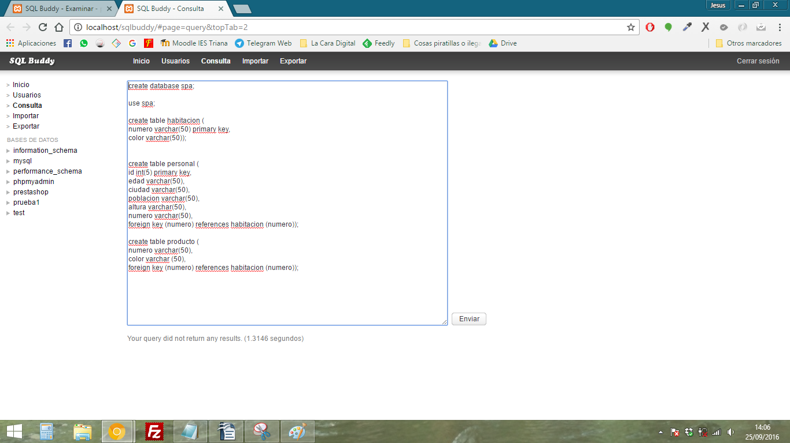

- Fill each one of the different table with at least 5 rows (Add a snapshot for each table's content).

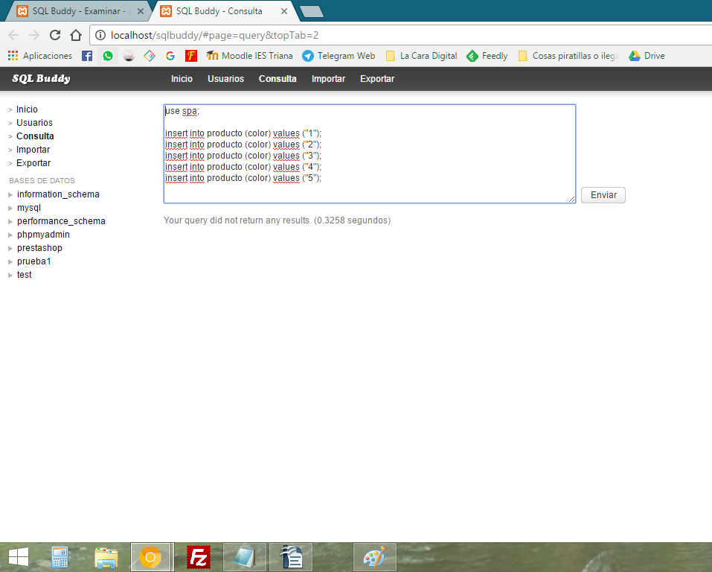

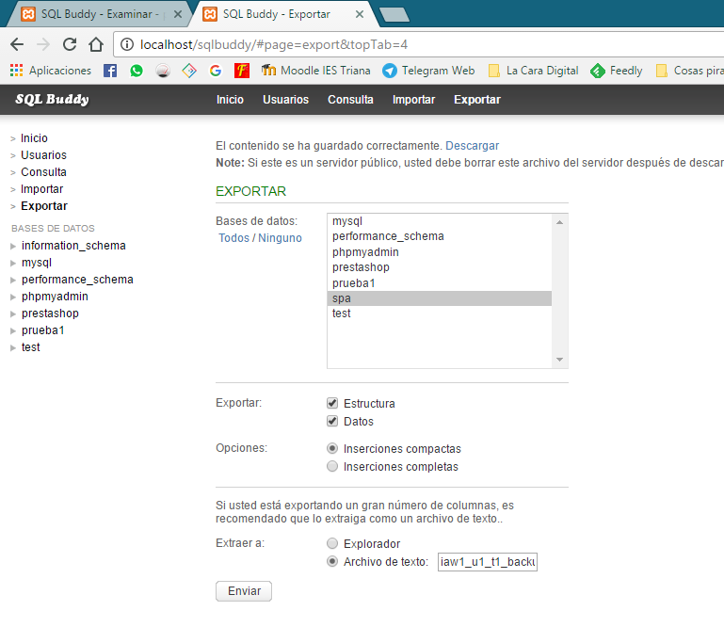
3. Create a database backup named like this (iaw1_u1_t1_backup_name_surname.sql).

Adjunto copia de seguridad junto a esta memoria.

4. Create a snapshot of main screen of the app in this snapshop point out which are the main CSS divisions. You should use Chrome's of Firefox's Developers tools for this part.

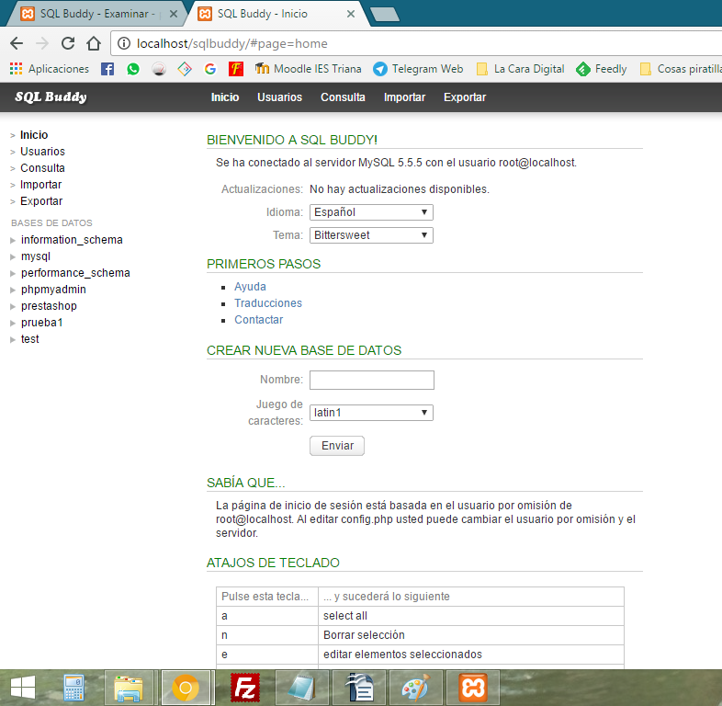

- Change the CSS and create a different version of the main screen: You must find where is the CSS file of the installed WebApp.Create a snapshot for this new vesion.

Esta es la antigua interfaz:

Siguiendo la ruta C:\xampp\htdocs\sqlbuddy\themes\bittersweet\css\main.css se encuentra el CSS de la interfaz de SQLBuddy.

Desde la consola de Google Chrome identifico las clases correspondientes a las partes de la web. Cambio tres clases; .dblist ul li a .menutext , #toptabs ul li a y h3, h4.

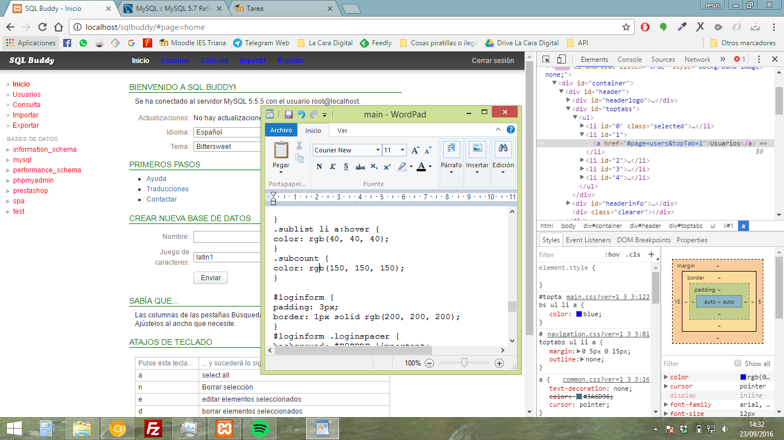
De modo que al refrescar la página se vería de la siguiente forma;

